FORMULA JUNIOR HISTORIC
RACING ASSOCIATION

4 Wool Road
Wimbledon London
SW20 0HW

Tel: 020 8946 1730
Fax: 020 8946 2367
Website: www.formulajunior.com
E-mail: rabagliati@blueyonder.co.uk

FORMULA JUNIOR NEWSLETTER

Newsletter #126 August 2006

FIA LURANI TROPHY

We received an acknowledgement from the FIA Head of Legal Affairs to say that Mr de Connink would be away on holiday till the end of August, and we would be hearing from him thereafter [ when he has got through reading all the letters and Emails in support…!!]

John Hughes, the Chairman of the committee set up by Max Moseley to consider the future of Historic Car racing was a visitor to the FIA Championships at Mantorp Park, and was not in favour of FIA taking over the Lurani trophy….

We wait further developments……..

FJHRA ANNUAL LUNCH and AGM - Sunday 19th November 2007

This year we avoid , once again, the RAC London to Brighton Run , and Remembrance Sunday – only the HSCC Dinner/dance is the night before , but an easy double for the hardy partygoers

Acceptance forms attached

GOODWOOD “Swedish FJ Welcome Party” - Thursday - 11.45 am

One of the great traditions of Goodwood has been the welcome party given by the Swedish 500 boys [ and gals ] – this year, sadly, there is no 500 race, but Duncan ,Mair, Robin and Sue have just come back from racing in Sweden loaded with colourful snaps, and the herrings in sauces – so the tradition will continue. For the less hardy, there will be soft drinks as well. All FJ and 500 drivers and friends are heartily welcome to join us in the FJ paddock at 11.45 –a shade earlier this year , as our Goodwood hosts now seem very kindly to provide lunch in the mess, even on the Thursday

As for the racing there is the usual wide variety of unusual cars , with the front wheel drive Bond, the PLW [ built originally for the 750cc s/c Formula One category !!] ,a Mitter, with Gerhard Mitter junior in attendance ,and a Yimkin making their Goodwood debuts

From: Neil R. Hodges [neilly_hodges@sapiens.co.uk]
Duncan,
A long shot and, as it happens, I don’t have too much time free but if you know of anyone who needs a helping hand on Friday or Saturday at Goodwood, please let me know.
Best wishes,
Neil Hodges
Sapiens "The Insurance Technology People"
 +44 (0) 789 463 7237
 neilly_hodges@sapiens.co.uk
Harman House, 1, George Street, Uxbridge, Middlesex England UB8 1QQ

DIJON LURANI Test Day
EuropeanF2 have let us know, that they have booked a testday at Dijon in advance to the "Trophées Historiques de Bourgogne"(6.-8.10), wednesday the 4th of October!

There will be 3 to 4 test groups:

1. beginners
2. race cars
3. saloon cars
(4. perhaps, depends how many drivers will be engaged)

every group will drive in minimum 4 x 25 minutes

costs € 300.- / per driver

registrations please to

info@europeanf2.com or

klaus.fiedler@europeanf2.ch

--

DEBDEN SPRINT- FJ Sprint/hillclimb Championship 2006 – Round 4

Please find attached regs for the final Debden Sprint event this year. Tony Staines [tony@stainest.freeserve.co.uk] writes to say that places normally fill very quickly for the October event.

Race Report from the 34th OldTimer Grand-Prix meeting at Nurburgring -----11-13th August 2006

The weather did not manage to stop the racers and spectators enjoyment of the three day meeting, The majority of Formula Junior arrived during the afternoon and evening of Wednesday and with the assistance of the paddock assistants swiftly established their base camps. Cars were given a polish to set them off at their best for the knowledgeable spectators to view as well as to query enable them to slice cleanly through the air and reduce their lap times.

Friday qualification: whilst in assembly we could see the rain advancing across the valley so it did not come as much of a surprise when rain began to fall on lap two. The canniest of our runners managed one quick lap at the start which proved to be the fastest possible under the torrential conditions that prevailed for much of the session. . All forty-two runners managed automatic qualification, with Urs Eberhardt s Lotus 27 taking pole from Michael Hibberd, also driving a Lotus 27 and Jorgen Carlsson’s Lotus 20, so with only 41 allowed on the grid, it looked as though David Brown (BT6), as first reserve , would be the unlucky one.

The spectators were equipped for a wet bank holiday in Whitby rather than mid-summer in Germany! By mid-morning the rain had stopped and glimpses of the sun were caught through chinks in the somber clouds. However the weather continued to try and dampen the enthusiasm with thunderstorms and intermittent rain throughout Friday and much of Saturday.

Race one on Saturday took place on a damp track with the start of a drying racing line. Urs Eberhardt took an early lead and sustained it to take the flag from a battling Emanuele Benedini (Brabham BT6) and a fast improving Chris Drake (Lotus 20) who elevated himself from 12th on the grid to claim the 3rd podium place. Andrew Hibberd (22) had been going very well and was up to 3rd position in the early stages of the race but spun out on Lap 7 at the Ford curve to end his race in the gravel trap. His father Michael (27) also spun on Lap 2 but managed to gather things together and finish in 9th, Michael fought to regain position but found it difficult to pass slower cars as to go off the racing dry line almost surely risked a spin. Mark Woodhouse (20) was slowed by an intermittently sticking throttle which caused him great consternation and was to plague him in race two. Martin Walford (Elva 200) kept out of trouble and won his class (C) as did Martin Carter (Lynx 3 – Class D), Jason Wright (Stanguellini) took the honours in the front-engined cars with Italian engines. Kevin Musson’s 18 was the only permanent casualty, with a broken upright, after contact with Marc Buhoffer following a spin , although poor Marc found ( too late ) that he , too, had suspension damage , when he T-boned Duncan at the chicane, fortunately without terminal consequences, thanks to some spirited assistance from Urban Fassler’s team, orchestrated by Tony Steele
Race 2 Sunday morning found the paddock almost in whiteout conditions from fog. In the media centre several of the televisions were broadcasting an almost blank screen which gave a good indication of conditions around the circuit. Unsurprisingly racing was postponed until 10 am. This suited Don Thallon who had worked most of the night to install a borrowed gear-box into his Cooper T56 and was now able to make it to assembly. Finally the juniors assembled , with David Brown replacing Kevin, but more drama was to occur when the officials discovered that Peter Strauss was improperly dressed,( it seems they just throw on a kangaroo skin down under !! ) Peter Larder managed to borrow regulation underwear from Robin Longdon, and a quick change behind a tent enabled him to make the grid by the skin of his teeth, although all this excitement was to prove too much, as Peter expirted up the pit road after one race lap, perhaps having flicked the “off” switch in error This time the track was dry but it was very cold for the team members on the pit-wall. Urs Eberhardt stormed away and took the flag over seven seconds ahead of the second placed driver Michael Hibberd who nine seconds in front of Robin Longdon (Lola Mk 5A). Many drivers were having their own little head to heads during the race and one in particular caught the imagination of the commentator, Johannes Hubner, who broadcast “the Dutchman van Gelder has just had the Englishman for breakfast – ah! – Just a moment – the breakfast was too much for him, he spun off!” Robin and Erwin van Gelder (Lotus 20/22) tussled for several laps before Robin took the advantage of Erwin’s spin to claim the final podium place. Chris Drake could not consolidate his third place of race two, being let down by a broken driveshaft on lap five. Don Thallon had gear selection problems that prevented him challenging Martin Carter who won Class D, with a lap advantage over the fast improving John Chisolm (Gemini Mk 111A) second, all Martin had to do was keep the car on the island and cruise to the line. Following the drama in assembly, Peter Strauss’s day only deteriorated, all this excitement proving too much, as Peter expired up the pit road after one race lap, perhaps having flicked the “off” switch in error but wary of possible expensive noises from his engine .Peter has now returned to Australia bur vows to return again in 2008. Martin Walford drove carefully to ensure first place in class C. This gave him a further 10 points in the Lurani trophy, five out of races with maximum points, thus unassailable with two rounds to go. Michael Ashley-Brown (Volpini) sheared two spark plugs in yesterday’s race and today stopped with a loss of oil pressure. Giancarlo Galeazzi (Lotus 22) had a lucky escape when a stone flew up and broke his glasses; he finished the race with blood streaming down his cheek and unable to see out of one eye.

RESULTS
1st 2nd 3rd
Race 1
Class A: Jason Wright Bruno Ferrari Michael Ashley-Brown
(Stanguellini) (Stanguellini) (Volpini)
2:30.064 2:36.039 2:34.672
Class B: Tony Goodwin Tony Steele Heinz Stege
(Gemini Mk 11) (Lola Mk 11) (Elva 100)
2:22.582 2:27.548 2:28.337
Class C: Martin Walford Peter Knöfel Andrew Taylor
(Elva 200) (Emeryson) (Britannia)
2:24.721 2:27.730 2:28.821
Class D: Martin Carter John Chisholm David Pratley
(Lynx Type 3) (Genini Mk 11A (Lola Mk 11)
2:23.001 2:24.391 2:29.925

Class E & Urs Eberhardt E. Benedini Chris Drake
Combined (Lotus 27) (Lotus 27) (Lola Mk 5A)
2:14.989 2:14.459 2:17.430
Race 2
Class A: Jason Wright Bruno Ferrari Maurizio Piantelli
(Stanguellini) (Stanguellini) (Stanguellini)
2:24.101 2:29.880 2:32.059
Class B: Erik Justesen Tony Steele Heinz Stege
(Mallock U2) (Lola Mk 2) (Elva 100)
2:17.366 2:18.714 2:18.647
Class C: Martin Walford Peter Knöfel Andrew Taylor
(Elva 200) (Emeryson) (Britannia)
2:12.909 2:21.002 2:20.638
Class D: Martin Carter John Chisholm David Pratley
(Lynx Type 3) (Genini Mk 11A) (Lola Mk 11)
2:20.822 2:17.533 2:23.639
Class E & Urs Eberhardt Michael Hibberd Robin Longdon
Combined (Lotus 27) (Lotus 27) (Lola Mk 5A)
2:06.949 2:05.851 2:07.547

Results
Race 1&2
Class A: Jason Wright Bruno Ferrari Maurizio Piantelli
Class B: Erik Justesen Tony Steele Tony Goodwin
Class C: Martin Walford Peter Knöfel Andrew Taylor
Class D: Martin Carter John Chisholm David Pratley
Class E &
Combined Urs Eberhardt Emanuele Benedini Marcus Mussa

Once again the Oldtimer Grand Prix proved to be a hit with Formula Junior despite the weather. All drivers plus a guest were given a pass to the driver’s club which provided breakfast, lunch and afternoon tea as well as local wine and beer and soft drinks all weekend.

SNIPPETS:
Thanks to Robin and Sue Longdon for the loan of their scooter, and Tony Steele for volunteering as chauffer to taxi me to the media signing on hotel. Tony’s bike skills saved our bacon when, riding through the tunnel under the track we found a lake of oil and safely snaked through.

Andrew Hibberd is trying to turn this write up into a lonely hearts column – so as promised Andrew! –“Wanted young lady interested in cars, historic motor racing, preferably independently wealthy or with expectations, GSOH to meet young petrol head with car”.

CONGRATULATIONS TO MARTIN WALFORD – LURANI TROPHY CHAMPION 2006

Jill Carter August 2006

MONTEREY – August 2006 – Report from Dan Chapman

This year was a very special Monterey , organized by Steve Earl. – not only was COOPER the favoure marque, but there was a dedicated Formula Junior and 500ccF3 race. Duncan asked Dan to write up on some of the less familiar FJs there, and on the race as a whole, so here is his report

Cooper Formula Junior T56, Serial No. F/J 61-10, manufactured March 1961
shipped to Briggs Cunningham; raced in the US from 1961-62, driven by Walt Hansgen

It was purchased in 1962 by the current owner, Richard Eisenmann, who raced until 1965, and then he restored it in 2001. It has a Fiat 1100 cc engine and looks to be very original, fiberglass body car. 5 speed, converted to De Tomaso. It has both left and ride side gas tanks. It has an interesting gear change cage (gate) with a lockout for reverse. It appears to have a chassis plate on the driver’s right side, on the upper longitudinal main frame member.
It is a drum brake car.

There were two Dolphin Formula Juniors. Dolphin Formula Junior Chassis No. 009, raced first in October 1960. It’s a rear engine, drum brake car presently owned by Phil Binks. It’s got a Ford 105 (rear engine), 4 speed, nicely stored, original chassis, original body. The present owner bought it in 1981 in pieces and recently has gone through a full restoration and is presently in factory livery. Raced by Ken Miles in period.

1961 Dolphin International Formula Junior Mark II. Present owner, David Woodhouse ,originally from UK, but now well established with the Ford design office, now living in Newport Coast, California. The engine is also a Ford, it’s a rear engine. Fully restored. I don’t see a chassis number on it or chassis plate on it. It’s got a scuttle mounted aluminum tank and drum brakes.

1960 BMC Mark I. Current owner, Carl Stirtz, Oakland, California. Engine BMC 4 speed, front engine. Present owner purchased it in 1972, and it has raced historically since 1974. Couldn’t find a chassis plate or a chassis number on it. [strange that we don’t know this car at all – hope our sleuths can tell us more of its period history ]

I just spoke with Richard Utley, who is here for the prehistoric and the big Saturday historic race that combined the Formula Juniors and the Formula IIIs. It was a grid of about 30, of which 6 were Formula IIIs. All but Richard Utley’s and John streets [ Staride ]were Cooper Nortons. Richard was racing his 1951 JBS Mark I, brought over from England. It is a Norton long stroke 500 cc engine. Richard started well, the Formula III group, which started at the back but was soon catching up with some of the Juniors. On lap 6 of a 10 lap race, a Cooper broke an oil line and put oil down in turns 3 and 4, which resulted a half dozen spins, including a Lotus 27 of Philip Ribbs into the tire wall. At that time, Richard came through turn 3, caught the oil, and at about the same time, the valve on his fire extinguisher unthreaded and proceeded to dump the contents onto his clutch foot. Unperturbed Richard dropped the heel of his foot onto the valve, shut it off, and finished the race in fine fettle.

I started about 2/3 the way back in the grid in my T56 BMC engine Cooper and passed 3 or 4 cars immediately at the start and proceeded to swap places with a Ford engined Lotus 18. On lap 6, we hit the oil laid down by the Cooper and the Lotus in front of me started spinning, first one way, then the next, and ended up perpendicular on the race line. I took a choice and went hard to the inside and my tires stuck and I made it by him. However, his numbers looked about 6 feet tall, his eyes like alarm clocks, and I was so close I saw his life flash in front of me in a few seconds. (It was interesting, I could tell his wife a few things.)

The race was won by pole sitter Jimmy Dominguez in his T59 from a ’62 Brabham. I pulled into Jimmy’s pit stop after the race to congratulate him and was speaking with him and Jack Brabham when Speed Vision came up with their cameras and crew, and apparently mistaken me for the winner and asked if I would mind if they might interview me. I said I wouldn’t mind at all, but pointing to Jimmy, said “he won the race.” That was the last I saw of the Speed Vision cameras.

Tom Ellis had a just restored Cooper T56 Formula Junior FJ/1/61 at the track. The car was literally finished 3 days before practice. This car was purchased by Hap Sharp in January 1961, and first raced by Jim Hall of Mexico City in late-January. The remainder of the season, it raced with Hap Sharp. Among the other events, it was raced in Formula Junior race during the Sebring 12 Hour weekend in Florida. The car is restored under a Ford engine with a Cooper ERSA gearbox. It is currently in factory livery. It carries both left and right side fuel tanks. It has disk brakes on the front and drum brakes on the rear. The chassis plate on the frame member upright just underneath the dash.

Saturday in Monterrey is the day that brings most of the crowds and the featured races.

We had a Cooper parade that featured several hundred Coopers circling the course. About 50,000-60,000 attended the 3-days of racing, which featured about 500 cars entered. Jimmy Dominguez and Karol Andrews put on a great party Sunday at noon, with a terrific buffet, attended by several hundred Cooper aficionados, including Mike Cooper and Jack Brabham.

Sunday is a full day of racing, but near the end of the day, rigs are coming in to pick up car and crew, awnings are coming down, and racecars are getting packed up. In the late afternoon, our crew was sitting under the awning behind my T56, sharing Margaritas with a few other Cooper folks, when I spotted a solitary figure moving slowly down the paddock row stopping to admire the sundry racecars. The elderly gentleman wearing sunglasses and ball cap stopped before my Junior for several minutes quietly looking it over. I moved to his side and spoke loudly with him. “Beautiful car,” he said, “very original….Tell me the history of the car.” So, I spoke with Jack Brabham for several minutes about the car, while my pit crew dug out items and lined up for autographs. A great ending for a fun weekend.

NEW FIA LURANI TROPHY website

Kevin Musson [kevmusson@hotmail.com] has written reminding us of his new website
www.fia-lurani-trophy.com

Well worth a visit…..and Kevin has had access to the original FJHRE files from 1994 onwards…and , as he says , there was POLITICS even then – no doubt this era will be incorporated with much interest into the website

PHOTOS from MONACO and SILVERSTONE

Peter Melissen [ pieter@melissenfl.com ]

I left me a business card on the seat of my car in the paddock At the recent Silverstone Classic. He also took the liberty of taking one of mine, and was soon in direct contact.

They have been shooting the FJs at Monaco and Silverstone and are wondering whether any drivers will be interested in having track shots of their cars. Rather than collecting individual contacts points for all of them, they have offered , if possible, to organise a centralised mailing whereby they send you a number of thumbnail files (one per car most likely) which could then be distributed among the drivers
I am open for any suggestions how to reach the drivers without having to ask you for individual addresses, which for reasons of privacy you might not want to give.

As an example he added a file of my car at Silverstone

--
Pieter Melissen
Tel +31-181-217310
Fax +31-181-276362

 Aldreth Daily Press 
August 2006
Wanted: an awful lot of bits for an Elva 200 Formula Junior ! ! ! !
Man Walks !
On Tuesday the 15th August Aldreth man, Andrew Spence walked again for the first time in 11 months. Ably assisted by physiotherapists Louise Walker and Haley Litchfield, Spence was able to walk the length of the parallel bars four times, a distance of about 40metres. When asked about his achievements Spence said he was overjoyed, ‘All this hard work is now paying off’. Spence went on to formally thank his wife and his physiotherapists for their dedication and support. When asked what his next target was Spence replied ‘more of the same please’
Success at Silverstone
Sue and Andrew Spence supported by Nancy and Angie made a welcome return to the Historic racing car scene on the 28th July at the Classic meeting. .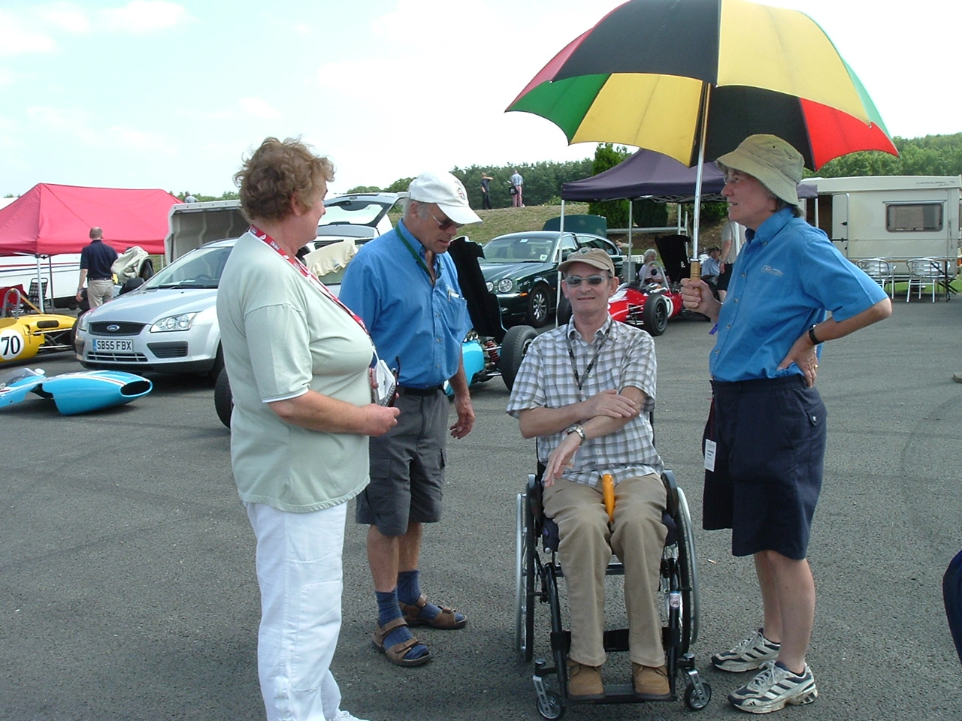
They were very pleased to see everyone again after such a long absence. Andrew was able to show off his newly acquired wheelchair skills and, thanks to David Watts, was able to have quite a few opportunities to lie down and relieve the back pain. He said it was interesting to look at F. Juniors from ground level. Sue took the opportunity to measure up Doug Martins car to see what all the bent bits on their Elva 200 should really be like.
A grand day out!

Mysterious Goings On at Local Hotel
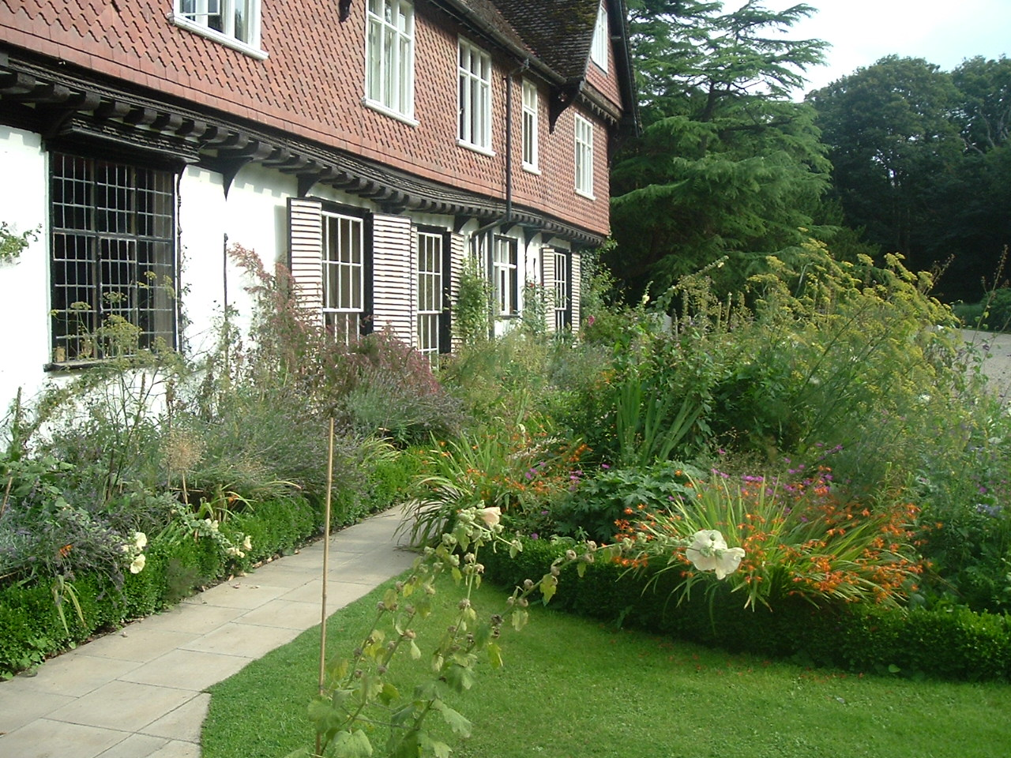

Strange goings on were seen at a local hotel where Mr and Mrs Spence were staying overnight on the 15th August 2006. Moira a maid at the hotel said that she was shocked by what she had seen. When asked about the affair Mrs Spence said she had booked the overnight stay at Roughham Hall as a surprise for her husband, she had only been under the sheets trying to sort out and make her husbands feet more comfortable.
Local Woman Starts Apprenticeship
Sue Spence has started the new apprentice scheme launched in Aldreth recently. The aim of the scheme is to help new recruits to learn engineering and mechanical skills. Sue has already learnt how to dismantle a car and was flushed with pride having been able to remove, single handed, the engine and gearbox from a Formula Junior. Using an angle grinder has proved her biggest challenge so far; she described it as an assault on the senses. Andrew Spence senior tutor is said to be pleased with progress, looks like Sue is destined to be teacher’s pet.

NEWS FROM USA

Renault gearbox specialist, J R Mitchell [ GMTRacing@aol.com ]writes

Things are going reasonably well over here with a busy summer.
I've only been out twice myself (Lotus18 fjr) at VSCCAs' Mt Equinox and Pittsburgh events. Took FTD at Equinox but no run below the magic 5 minute mark due to rain and fog. Pittsburgh went well with 14 juniors up to 1960 participating. I took class pole and finished first in class, second overall to Dick Fryberger in a Lotus XI 1500 in the combined sports racing/ formula junior race. Christian Morici came second, Robert Platrow third also in Lotus 18's.
I notice in the classified ads that the ex Joe Maria Lotus 20 is for sale and described as restored by myself. This car is being confused with Joes' Lotus 18 fjr that we did work on(now owned by Jerry Morici and driven by Christian Morici). Joe’s 20 was never in our shop. but Iwould appreciate a correction if the opportunity arises.

MERLYN Mk 5 in Singapore

Casting through the latest edition of the MSVCR magazine I chanced on a photo of the ex works 1963 Merlyn Mk 5 FJ [ with Mk 7 mods] racing in Singapore . The car had all the original and very distinctive Mk 5 body fitted still

Eli Solomon [eliyahu@netvigator.com] writes [07 August 2006 05:38 am]
Merlyn Mk”7” - You mean the car Rodney Seow ran in Asia (including Macao) ?- a three-way split between Opel agents Singapore Motors, Stanley Leong and Rodney Seow. The car was always recognised here as a Mk7. It ran a pushrod 1500cc with Hewland Mk4 box. Some of the photos show the car with the front end of the nose chopped off - a result of an accident during transportation between races across the casueway (Singapore GP to Batu Tiga I believe). Given length of the Singapore GP (60 laps), the car had four fuel tanks installed.
History:
The MERLYN Mk”7“was the ex-1962 works FJr fitted with a 1500cc pushrod. The car was sold to Robert Lee of Penang (1966), and then to Lionel Chan who crashed it and died in the 1972 Singapore Grand Prix. I haven't been able to locate the car in Singapore.
The Mk”7” had 4 fuel tanks for the 60 lap race - one on the front, two on the sides, and one as the seat - with Rodney sitting on it over padding.
Singapore Grand Prix 1966
Robert Lee - Merlyn FJr 1498cc (ex-Rodney Seow Merlyn Mk7)
NB: The Robert Lee Merlyn FJr was bought from Rodney Seow. Rodney doesn't recall seeing Robert ever run the Merlyn or a single-seater in Singapore however.

I had a tip off on where the car was sent to post Lionel Chan's accident in 1972 and on a trip back a couple of years ago I drove down to Lionel's sister's house to see if it was still there. No such luck. I did find the Daren however. As to whether or not the Merlyn is in Singapore - I'd like to think so but suspect that it was either sold or buried when they renovated/sold the house (that car had been craned over the house and parked in the backyard from first hand accounts). Now Rodney is still around though him memory isn't what it used to be. The Merlyn was his first single-seater and I have a number of interesting stories of the car which I recorded over our several conversations over the last two years. I've also got a number of photos of the car - one of which is the main photo in the Motorsport magazine article (March 2006) of him leading the 1964 Singapore Grand Prix.

NEW ZEALAND News - Ian Garmey

Already it is less than four weeks to the opening of our 2006-07 season - the Historic Racing Club's Icebreaker at Pukekohe, 16 and 17 September, entry forms are available at www.grandprix.org.nz if you haven't received yours yet. Entries close on 8 September, 2006. If you have entered, or intend entering, would you please advise me by e-mail (garmey@xtra.co.nz) so we can request enough paddock space.

A copy of the 2006-07 historic competition calendar is attached if you are not on Jim Barclay's e-mailing list.

Keith and Craig Abbott have had a busy off-season rebuilding the Lotus 18's gearbox and installing a new set of ratios. Craig and his team at Republik Communications have also completed our new banners and produced a range of NZFJR car stickers, be sure to see Craig about purchasing yours at the Icebreaker event.

Wayne Rodgers is spending plenty of chilly winter nights in the workshop making good progress on the Lynx and is need of a set of 9in x 1.5in alloy brake drums, or information as to what road cars used aluminium drums of these dimensions. Tel. 0923-82595.

The secretary of the Australian Formula Junior Association, Kelvin Prior, has been in touch to advise that their association is lobbying the organisers of Sydney's Eastern Creek Tasman Revival meeting to change their entry conditions for New Zealand entrants to the event in January. Apparently 25 Formula Juniors are required before an FJ-only race will be scheduled.

Sadly we have two passings to report ... Ralph Watson, very much a part of New Zealand's motorsport history passed peacefully away on Wednesday (23 August). Ralph's funeral will be held at Purewa at mid-day, Friday, 25 August. John Dymand, CEO of Penrite Oil and the owner of a Invercargill-based Elfin Catalina Formula Junior died in Australia during June. [ How very sad – Duncan met Ralph on his 1990 Antipodean trip, and travelled with him in his amazing technically advanced self built car ]

More sad news of a different vein, the ex-Bryan Thomas/Dene Hollier Lotus 27 which has been with Andrew Cunningham in the South Island has been sold to Michael Schryver in the UK.

The 2006-07 NZ historic competition calendar is as follows

NZ RACE CALENDAR FOR HISTORICS 2006/2007
Dates marked *FJ are points meetings for the FJ ‘Championship’ (To Be Confirmed)

27 Aug 06 – Bruce McLaren Trust Annual Coast to Coast fun rally. This is the fourth running of this event, to be held on the weekend closest to Bruce’s birthday each year. Something for you to do while the racecar is having a freshen-up. Entries were closed off last year so get yours in early. Contact Jan McLaren at the Bruce McLaren Trust brucemclarentrust@clear.net.nz for further details.

16/17 Sep 06 HRC Pukekohe – F5000/Libres, Historics etc
+FF call Chris Watson 09 4414 579 for details.

7/8 Oct 06 TACCOC Spring Classic Taupo –
* FJ see TACCOC website for entry form or contact Jim Barclay. jimbarclay@xtra.co.nz

11/13 Nov 06 MG/Whitakers Manfeild – for entry forms/details
* FJ call Nigel Russell 09 418 0676 Home, 09 480 4384 Work

27/28 2/3 Dec 06 HRSCC Taupo – call Ray Hawke 09 294 7446 for details, or check HRSCC *FJ website for entry form.

27/28 Jan 07 HRC Pukekohe – Tasman GP F5000 International.
*FJ

Feb 07 Southern Festival of Speed (SFOS) – dates TBA.

18 Feb 07 HRSCC Kellyville Road Hillclimb – Pokeno/Mercer – Contact Nigel Russell/Ray Hawke

10/11 Mar 07 TACCOC Classic Wheels Taupo
*FJ email Jim Barclay for entry if needed

17/18 Mar 07 HRC meeting Pukekohe –
*FJ Call Chris Watson for entry if needed.

13 Apr 07 TACCOC - Pukekohe
*FJ

XX May 07 HRC Domain Hillclimb Auckland for Pre 1990 cars. See HRC Website or Chris Watson for entry details

15 May 07 TACCOC & MG 2.04 Hour ‘LeMans’ Pukekohe

Sep 07 HRC Icebreaker Pukekohe

6/7 Oct 007 TACCOC Spring Classic Taupo

Rare FOR SALE opportunity ------------GEMINI Mk II

Gemini Mk 2  # 1018 | 1959 front engined Swiftune BMC 1071cc; Jack Knight dog-box; strengthened transmission; special dif + spare ;new suspension; new hydraulics; new electrics, instruments,brakes,hydraulics; Transponder. Comprehensive spares include 8 ali wheels/tyres ;nose cone mould and 3 spare nose cones [ different lengths – Monaco, etc !!!]; new front and rear uprights, steering arms, stub axle,etc; wishbones, suspension units, drive shafts, brake shoes, etc; radiator; Goodwood silencers; original seat; Successes include Nurburgring,Spa,Pau,Oporto,Angouleme,Donington Park PRICE £ 49,500 [ much less than a Lola !!] Extra [ by negotiation] original 1098cc engine, not run since Swift rebuild and bench test; Jack Knight gearbox, used twice since rebuild ; Castings for dif. Casing, dropbox,backplates; patterns for dif.casing, dropbox, backplates, rear upright, brake drums contact Dr Tony Goodwin mob +44 (0)7850 312178 Em tony.goodwin@btinternet.com

Tony is now looking for a new Formula Junior challenge – a Lola , perhaps, like the one , now owned by David Pratley, that he drove in period , and created such a sensation at the 1964 Formula 3 Monaco race

DCPR

